* Required Components of Annual Financial Reports

The following are two new versions of the Required Components of Annual Financial Reports graphic (Figure 1 in the illustrated statements) that may be appropriate for a charter school. They are provided to assist preparers and as an alternative presentation to consider when drafting the MD&A in the financial statements. The Figure 1 presentation from financial statements from prior years is included and is still appropriate.

Each is a Picture (Enhanced Metafile). If you agree with the illustration’s concept, text selection, layout and terminology, the Picture is very easy to copy, paste, resize, etc. While the picture’s size can be easily changed, the text, font, etc. are difficult to change.

The “pictures” can be easily inserted into its own paragraph in a charter school’s MD&A by clicking on the picture and using the Word Copy and Paste commands. To adjust the size, select a corner of the document and resize — this will keep the text in the proper proportion. You can also “crop” the picture.

1. For a charter school providing pension benefits.

a. Cardinal Charter, Inc. (Font: Times New Roman)



b. Owl Charter, Inc. (Font: Arial)

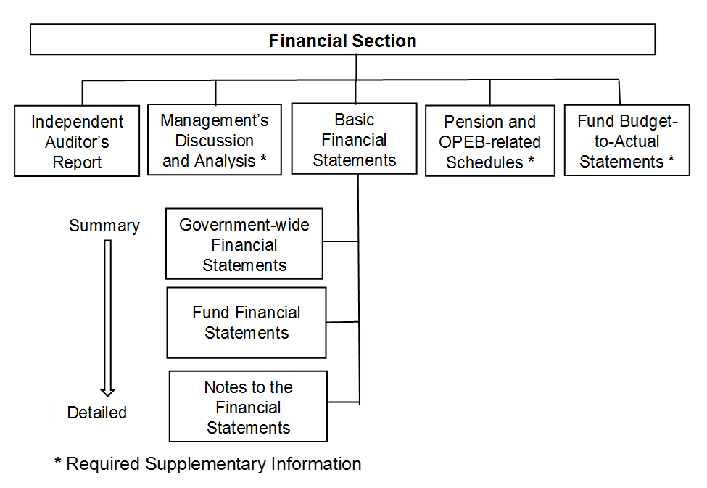

2. For a charter school NOT provide pension benefits.

a. (Font: Times New Roman)

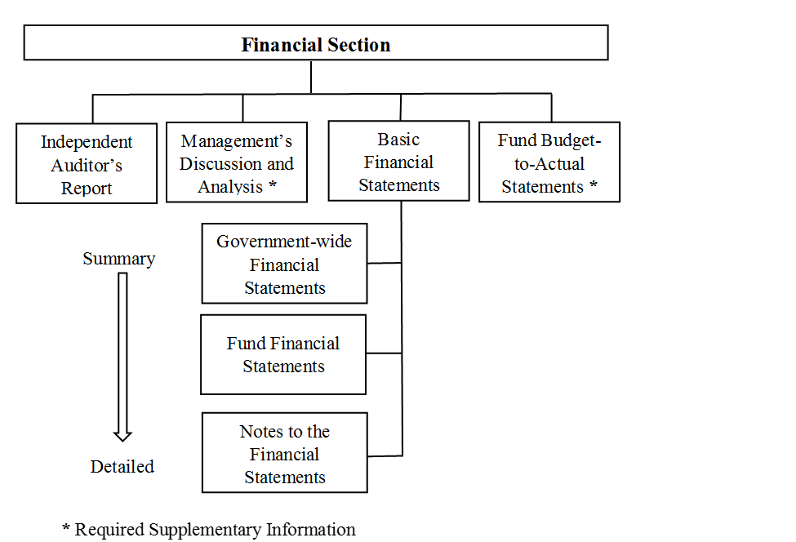

b. (Font: Arial)

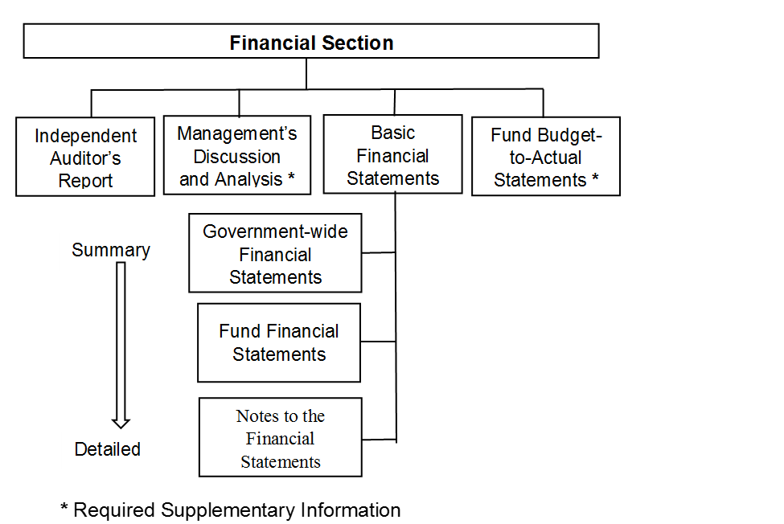

3. The current version as a Picture (Enhanced Metafile).

a. (Font: Times New Roman)



b. (Font: Arial)

